​
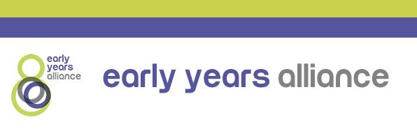

The Department for Education has provided the below response to queries on why early years providers have been asked to remain open while schools have been instructed to close, following our meeting with children and families minister Vicky Ford earlier today: 5th January 2021.

- The reason schools have been restricted is not that they are unsafe but because additional measures are needed to contain the spread of the virus. The wider restrictions in place as part of the national lockdown to contain the spread of the virus in the community enable us to continue prioritising keeping nurseries and childminders open, supporting parents and delivering the crucial care and education needed for our youngest children.
- Early years settings remain low risk environments for children and staff. 0-5 year olds continue to have the lowest confirmed rates of coronavirus of all age groups, and there is no evidence that the new variant of coronavirus disproportionately affects young children. Evidence shows that pre-school children are less susceptible to infection and are not playing a driving role in transmission. There is no evidence the new strain of the virus causes more serious illness in either children or adults and there continues to be strong evidence that children are much less susceptible to severe clinical disease than older people.
- PHE advice remains that the risk of transmission and infection is low if early years settings follow the system of controls, which reduce risks and create inherently safer environments.
- Early years settings have been open to all children since 1 June and there is no evidence that the early years sector has contributed to a rise in virus cases within the community. Early evidence from SAGE showed that early years provision had a smaller relative impact on transmission rate than primary schools, which in turn had a smaller relative impact than secondary schools.
- Early years childcare providers were one of the first sectors to have restrictions lifted last summer, in recognition of the key role they play in society. Childminders and nursery staff across the country have worked hard to keep settings open through the pandemic so that young children can be educated, and parents can work. The earliest years are the most crucial point of child development and attending early education lays the foundation for lifelong learning and supports children’s social and emotional development. We continue to prioritise keeping early years settings open in full because of the clear benefits to children’s education and wellbeing and to support working parents. Caring for the youngest age group is not something that can be done remotely.

